**CS 207: Applied Database Practicum**

**In-Class Activity 6: Introduction to Triggers, 30th September, 2019**

In this activity, you will be working in Mysql.

Load the dump file (join.sql) from moodle.

Q1. Create a table named **employee_audit** thatkeeps track of any updation made to the **employees** table. The **employee_audit table** should have the following schema:

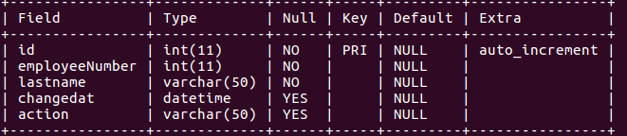

Create a BEFORE UPDATE trigger that is invoked before a change is made to the **employees** table. This trigger when invoked should insert into **employee_audit** the employeeNumber, Lastname of the employee and the time at which the record was updated into the **employees** table. Also SET action value to update

e.g if the below given query

**UPDATE employees SET lastName = 'Patterson' WHERE employeeNumber = 1056;**

is executed. Then the employee_audit should contain the following values:

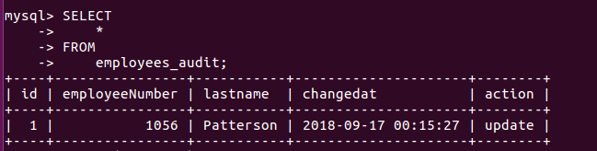

Q2. Load the dump file (dump.sql) from moodle.

The database is named **d1** and contains the following tables:

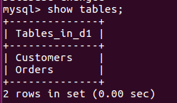

Create a table named **customer_audit** thatkeeps track of any row deletion made to the **Customers** table. The **customer_audit** table should have the following schema:

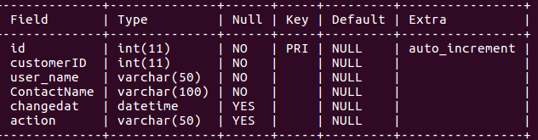

Create an AFTER DELETE trigger that is invoked after a record is deleted from the **Customers** table. This trigger when invoked should insert into **customer_audit** the CustomerID, Contact_name of the customer and the time at which the record was deleted from the Customerstable. The user who deleted the record should also be inserted into the **customers_audit** table. Also SET action value to **delete.**

if the below given query:

**DELETE from Customers where CustomerID=1;**

is executed. Then the **customer_audit** should contain the following values:

